ASTRA INTERIORS
Mr. Manoker – Wardrobe cut list (4 bedrooms)
Date: 07-11-2026
Wardrobe | Width | Height | Cupboard box | Loft | Pieces | 18 mm sheets | 6 mm sheets | LED strip
GF Bedroom | 2526 | 2857 | 2000 mm | 90 mm frame, 857 H | 60 | 6 | 3 | 3 pcs / 5.22 m
1st Floor M.Bedroom | 2349 | 2905 | 2000 mm | 90 mm frame, 905 H | 54 | 5 | 2 | 3 pcs / 5.08 m
1st Floor Bedroom 2 | 2319 | 2895 | 2000 mm | 90 mm frame, 895 H | 54 | 5 | 2 | 3 pcs / 5.08 m
2nd Floor Bedroom | 2349 | 2825 | 2000 mm | 90 mm frame, 825 H | 54 | 5 | 2 | 3 pcs / 5.08 m

- Board: 18 mm ply for all carcass, shelves and drawers. Back panels: 6 mm ply in a 6 mm groove all round (size includes +12 mm).
- Depth: all wardrobes 500 mm (side / top / bottom). Full-height partitions = 500 (same as side panel, doors are fixed on them; 6 mm back-panel groove on both faces). Inside partitions (dressing / bangle column) = 494. Shelves = 474 (set back 20 mm).
- Every wardrobe is a CUPBOARD BOX 2000 mm high (an 8 ft ply sheet is only 2400 mm long).
- LOFT above the cupboard = 90 mm FRAME ONLY: 90 mm uprights at the ends and partitions + 90 mm top and bottom rails. No loft box, no loft back panel. Loft floor = cupboard top panel.
- GF Bedroom is wider than 2400 mm, so it has 2 cupboard boxes side by side and the loft rails are in 2 pieces – no piece is longer than 2400 mm.
- LED strip-light groove: one vertical groove per cupboard section, 12 mm wide × 8 mm deep, 100 mm from the front edge, on the side / partition face.
- Drawers: bottom 2 drawers only in every bedroom, opening 173, drawer box 150 high. 18 mm frame (sides + front/back inner) with an 8 mm wide x 10 mm deep groove: leave 12 mm from the bottom edge, groove from 12 to 20 mm; the 6 mm drawer bottom slides into the groove (size = inside + 18 mm: 10 mm groove each side, 1 mm play).
- Cut L / Cut W = panel-saw size (front edge minus 0.5 mm edge tape). Add saw kerf when marking out.
- Shutters: 6 doors per bedroom (2 per section), 18 mm ply + laminate, full overlay, 3 mm gaps, 2 mm edge tape on 4 sides (Cut = finished - 4 mm). Drawer section: doors only above the drawers; the 2 drawers have outside fronts in shutter material.

GF Bedroom wardrobe
2526 W × 2857 H × 500 D · cupboard box 2000 mm + loft 90 mm frame only · cupboard clear 1884 mm
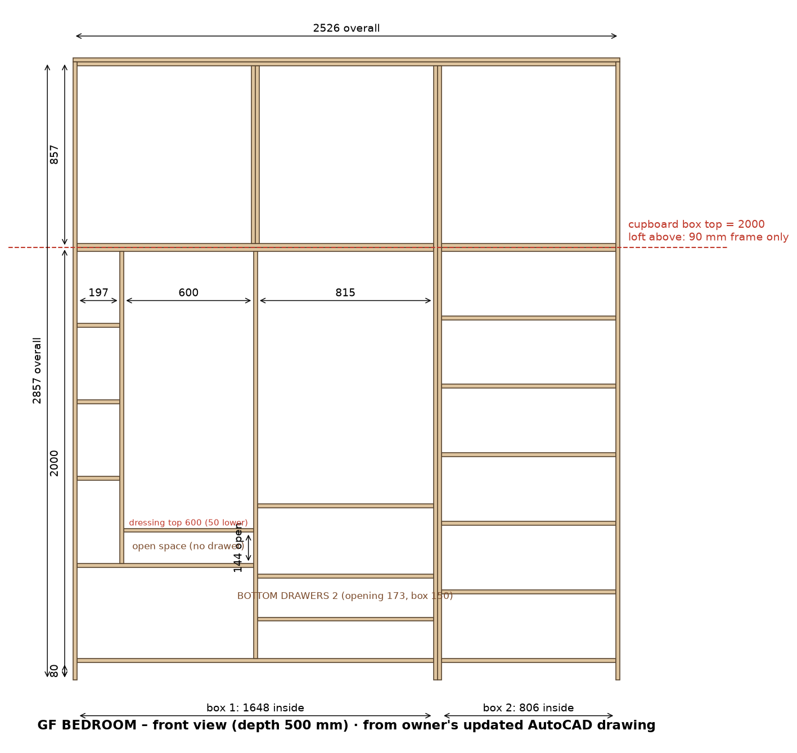
2D drawing (owner's AutoCAD): cupboard box 2000 mm high; loft above = 90 mm frame only (uprights + top/bottom rails). LED strip groove in each cupboard section.

GF Bedroom – shutters with Merino laminate
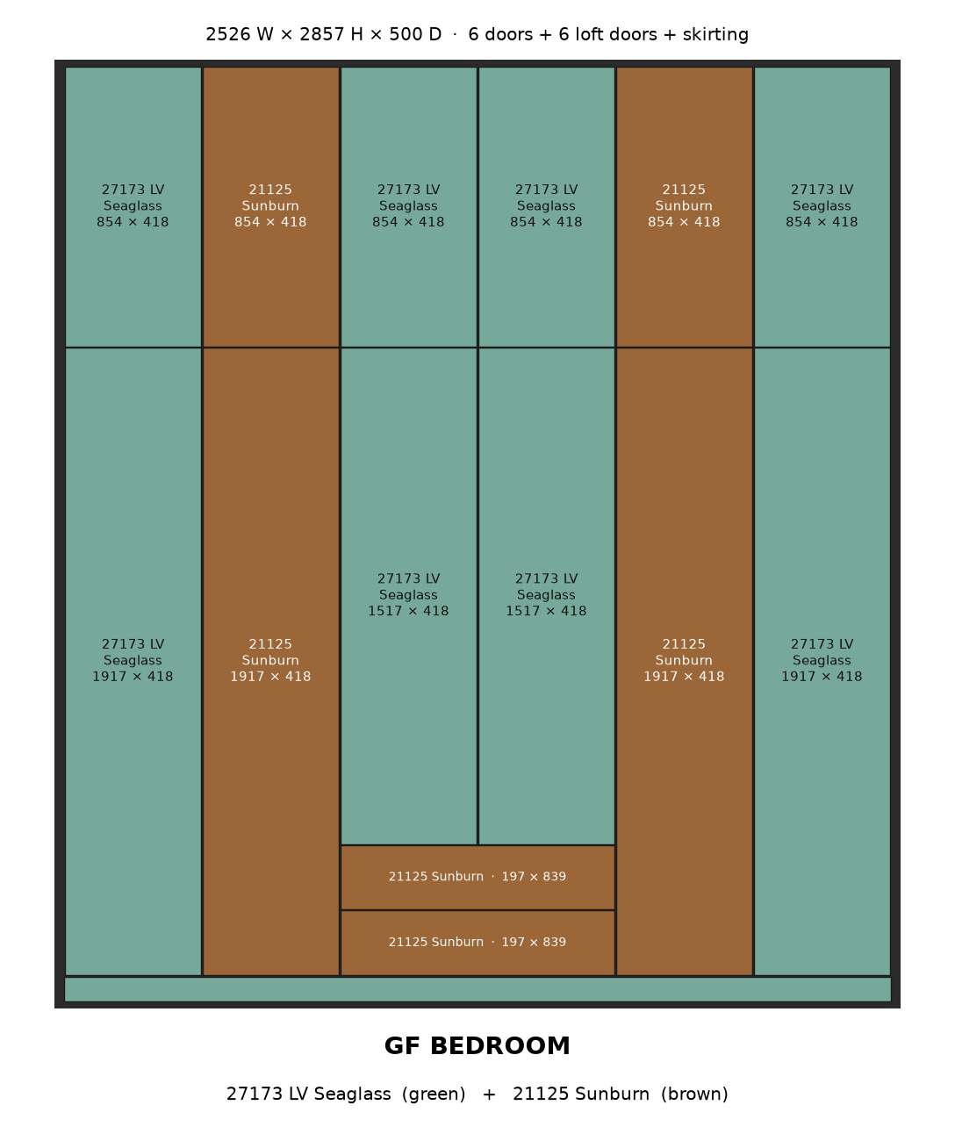

GF Bedroom wardrobe – cut list
# | Group | Part | Material | Qty | Finished L | Finished W | Cut L | Cut W | Edge band | Machining / note
Cupboard box
1 | Cupboard box | Side panel (cupboard, 2000 high) | 18 mm ply | 4 | 2000 | 500 | 2000 | 499.5 | 0.5 mm, 1 long
2 | Cupboard box | Partition (full height, doors fixed) | 18 mm ply | 1 | 1884 | 500 | 1884 | 499.5 | 0.5 mm, 1 long | 6 mm back-panel groove on both faces
3 | Cupboard box | Bottom panel | 18 mm ply | 1 | 1648 | 500 | 1648 | 499.5 | 0.5 mm, 1 long
4 | Cupboard box | Top panel | 18 mm ply | 1 | 1648 | 500 | 1648 | 499.5 | 0.5 mm, 1 long
5 | Cupboard box | Partition (inside) | 18 mm ply | 1 | 1444 | 494 | 1444 | 493.5 | 0.5 mm, 1 long
6 | Cupboard box | Bottom panel | 18 mm ply | 1 | 806 | 500 | 806 | 499.5 | 0.5 mm, 1 long
7 | Cupboard box | Top panel | 18 mm ply | 1 | 806 | 500 | 806 | 499.5 | 0.5 mm, 1 long
Loft frame 90 mm
8 | Loft frame 90 mm | Top rail | 18 mm ply | 1 | 1648 | 90 | 1648 | 89.5 | 0.5 mm, 1 long | fix to ceiling
9 | Loft frame 90 mm | Bottom rail (front, on cupboard top) | 18 mm ply | 1 | 1648 | 90 | 1648 | 89.5 | 0.5 mm, 1 long
10 | Loft frame 90 mm | Frame upright (end / partition) | 18 mm ply | 4 | 857 | 90 | 857 | 89.5 | 0.5 mm, 1 long | loft frame only - no box, no back panel
11 | Loft frame 90 mm | Top rail | 18 mm ply | 1 | 806 | 90 | 806 | 89.5 | 0.5 mm, 1 long | fix to ceiling
12 | Loft frame 90 mm | Bottom rail (front, on cupboard top) | 18 mm ply | 1 | 806 | 90 | 806 | 89.5 | 0.5 mm, 1 long
Inside
13 | Inside | Shelf | 18 mm ply | 4 | 815 | 474 | 815 | 473.5 | 0.5 mm, 1 long
14 | Inside | Shelf | 18 mm ply | 5 | 806 | 474 | 806 | 473.5 | 0.5 mm, 1 long
15 | Inside | Shelf | 18 mm ply | 1 | 600 | 474 | 600 | 473.5 | 0.5 mm, 1 long
16 | Inside | Shelf | 18 mm ply | 3 | 197 | 474 | 197 | 473.5 | 0.5 mm, 1 long
Back panels 6 mm
17 | Back panels 6 mm | Main back panel | 6 mm back ply | 2 | 1896 | 827 | 1896 | 827 | - | in 6 mm groove all round
18 | Back panels 6 mm | Main back panel | 6 mm back ply | 1 | 1896 | 818 | 1896 | 818 | - | in 6 mm groove all round
Drawers
19 | Drawers | Bottom drawers: drawer front/back inner | 18 mm ply | 4 | 753 | 150 | 753 | 149.5 | 0.5 mm, 1 long | groove 8 mm wide x 10 deep: leave 12 mm from bottom edge, groove 12-20 mm (6 mm drawer bottom slides in)
20 | Drawers | Bottom drawers: drawer side | 18 mm ply | 4 | 450 | 150 | 450 | 149.5 | 0.5 mm, 1 long | groove 8 mm wide x 10 deep: leave 12 mm from bottom edge, groove 12-20 mm (6 mm drawer bottom slides in)
21 | Drawers | Bottom drawers: drawer bottom 6 mm (in groove) | 6 mm back ply | 2 | 432 | 771 | 432 | 771 | - | inside size + 9 mm each side (10 mm groove, 1 mm play)
Shutters
22 | Shutters | Door (full height) - 27173 LV Seaglass (green) | 18 mm ply + Merino laminate (shutter) | 2 | 1917 | 418 | 1913 | 414 | 2 mm, 4 sides | concealed hinges, 3 mm gaps
23 | Shutters | Door (full height) - 21125 Sunburn (brown) | 18 mm ply + Merino laminate (shutter) | 2 | 1917 | 418 | 1913 | 414 | 2 mm, 4 sides | concealed hinges, 3 mm gaps
24 | Shutters | Skirting (front, base 80) - 27173 LV Seaglass (green) | 18 mm ply + Merino laminate (shutter) | 1 | 1684 | 77 | 1680 | 73 | 2 mm, 4 sides | fix on base, 3 mm below doors
25 | Shutters | Door above drawers - 27173 LV Seaglass (green) | 18 mm ply + Merino laminate (shutter) | 2 | 1517 | 418 | 1513 | 414 | 2 mm, 4 sides | concealed hinges, 3 mm gaps
26 | Shutters | Loft door - 27173 LV Seaglass (green) | 18 mm ply + Merino laminate (shutter) | 4 | 854 | 418 | 850 | 414 | 2 mm, 4 sides | on loft frame, 3 mm gaps
27 | Shutters | Loft door - 21125 Sunburn (brown) | 18 mm ply + Merino laminate (shutter) | 2 | 854 | 418 | 850 | 414 | 2 mm, 4 sides | on loft frame, 3 mm gaps
28 | Shutters | Skirting (front, base 80) - 27173 LV Seaglass (green) | 18 mm ply + Merino laminate (shutter) | 1 | 842 | 77 | 838 | 73 | 2 mm, 4 sides | fix on base, 3 mm below doors
29 | Shutters | Drawer outside front - 21125 Sunburn (brown) | 18 mm ply + Merino laminate (shutter) | 2 | 839 | 197 | 835 | 193 | 2 mm, 4 sides | fix on drawer box; handle
 |  | Total pieces |  | 60

Material | Area sq.ft / length | 8×4 sheets (15% waste) | Hardware / item
18 mm ply | 146.4 | 6 | LED strip light + aluminium profile (in grooves): 3 pcs, 5.22 m total
6 mm back ply | 57.6 | 3 | LED driver + door sensor switch: 1
18 mm ply + Merino laminate (shutter) | 76.9 | 3 | Soft-close telescopic channels 450 mm (pairs): 2
Edge tape 0.5 mm (front edges) | 42 m |  | Drawer handles / profile: 2
Edge tape 2 mm (shutters, 4 sides) | 57 m |  | Concealed soft-close hinges (doors): 40
 |  |  | Door handles: 6

LED strip light – profile groove cutting
Groove 12 mm wide × 8 mm deep, 100 mm from the front edge, vertical, on the panel face inside the section. Start is measured from the top of the bottom panel; groove runs up to the underside of the top panel. Drill a 10 mm wire hole through the top panel at the groove top. Keep shelf screws clear of the groove.
Section | Opening W | Panel | Groove on | From front | Groove start | Groove length | Profile + strip
1 | 815 | Side panel | right face (inside section) | 100 mm | 0 mm | 1884 mm | 1864 mm
2 | 815 | Partition | right face (inside section) | 100 mm | 373 mm (above drawers) | 1511 mm | 1491 mm
3 | 806 | Side panel | right face (inside section) | 100 mm | 0 mm | 1884 mm | 1864 mm
Total |  |  |  |  |  |  | 5.22 m

1st Floor M.Bedroom wardrobe
2349 W × 2905 H × 500 D · cupboard box 2000 mm + loft 90 mm frame only · cupboard clear 1884 mm
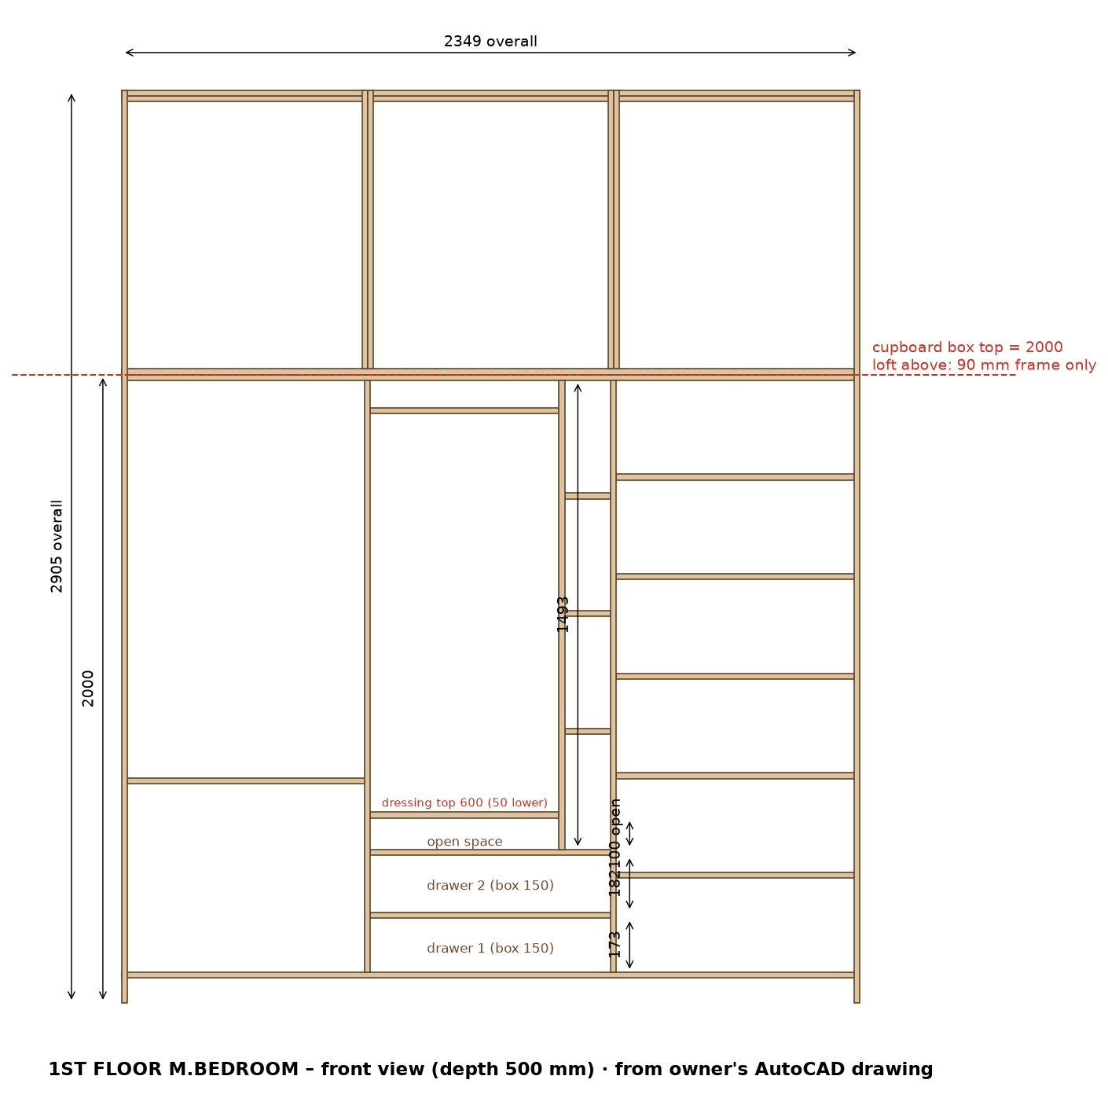
2D drawing (owner's AutoCAD): cupboard box 2000 mm high; loft above = 90 mm frame only (uprights + top/bottom rails). LED strip groove in each cupboard section.

1st Floor M.Bedroom – shutters with Merino laminate
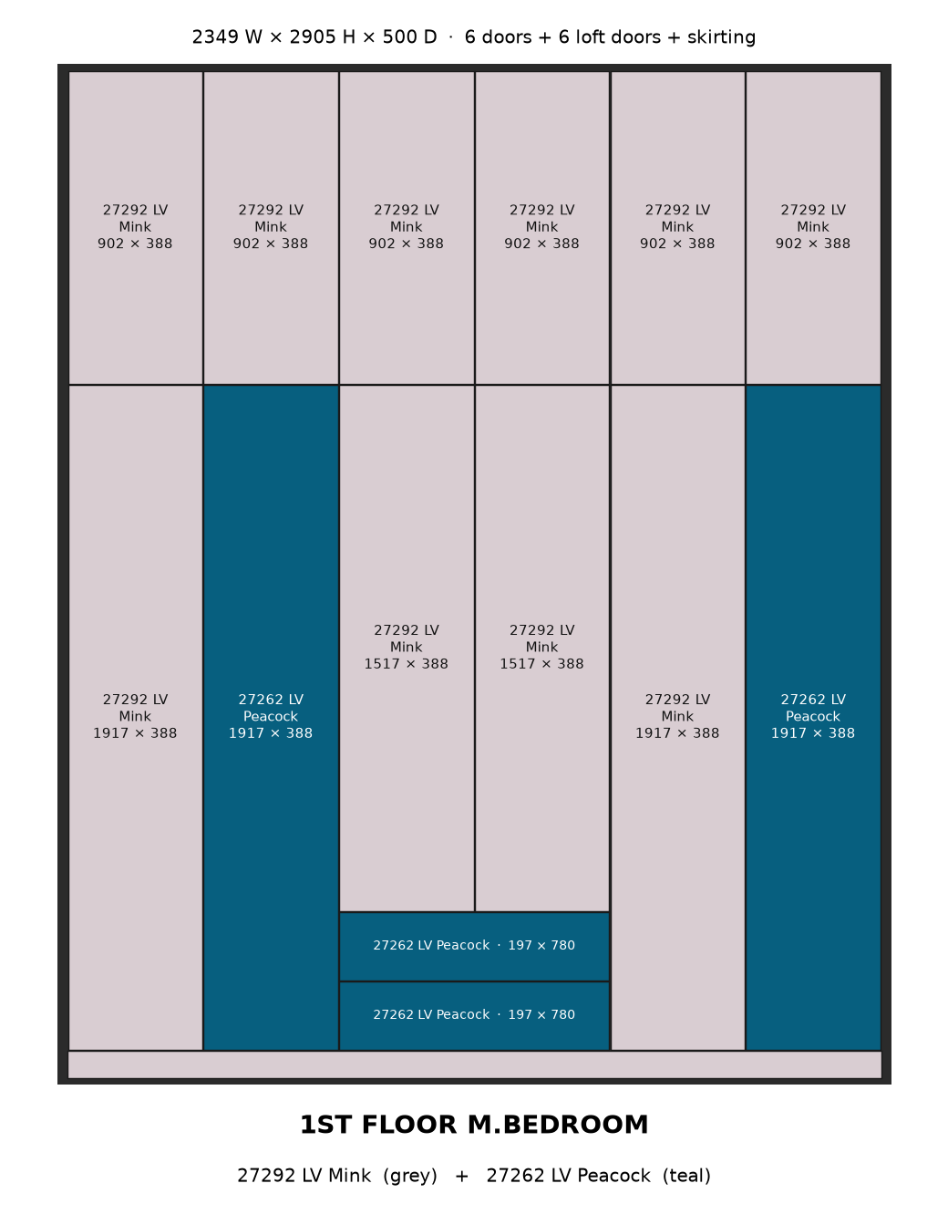

1st Floor M.Bedroom wardrobe – cut list
# | Group | Part | Material | Qty | Finished L | Finished W | Cut L | Cut W | Edge band | Machining / note
Cupboard box
1 | Cupboard box | Bottom panel | 18 mm ply | 1 | 2331 | 500 | 2331 | 499.5 | 0.5 mm, 1 long
2 | Cupboard box | Top panel | 18 mm ply | 1 | 2331 | 500 | 2331 | 499.5 | 0.5 mm, 1 long
3 | Cupboard box | Side panel (cupboard, 2000 high) | 18 mm ply | 2 | 2000 | 500 | 2000 | 499.5 | 0.5 mm, 1 long
4 | Cupboard box | Partition (full height, doors fixed) | 18 mm ply | 2 | 1884 | 500 | 1884 | 499.5 | 0.5 mm, 1 long | 6 mm back-panel groove on both faces
5 | Cupboard box | Partition (inside) | 18 mm ply | 1 | 1493 | 494 | 1493 | 493.5 | 0.5 mm, 1 long
Loft frame 90 mm
6 | Loft frame 90 mm | Top rail | 18 mm ply | 1 | 2313 | 90 | 2313 | 89.5 | 0.5 mm, 1 long | fix to ceiling
7 | Loft frame 90 mm | Bottom rail (front, on cupboard top) | 18 mm ply | 1 | 2313 | 90 | 2313 | 89.5 | 0.5 mm, 1 long
8 | Loft frame 90 mm | Frame upright (end / partition) | 18 mm ply | 4 | 905 | 90 | 905 | 89.5 | 0.5 mm, 1 long | loft frame only - no box, no back panel
Inside
9 | Inside | Shelf | 18 mm ply | 2 | 765 | 474 | 765 | 473.5 | 0.5 mm, 1 long
10 | Inside | Shelf | 18 mm ply | 6 | 756 | 474 | 756 | 473.5 | 0.5 mm, 1 long
11 | Inside | Shelf | 18 mm ply | 2 | 600 | 474 | 600 | 473.5 | 0.5 mm, 1 long
12 | Inside | Shelf | 18 mm ply | 3 | 147 | 474 | 147 | 473.5 | 0.5 mm, 1 long
Back panels 6 mm
13 | Back panels 6 mm | Main back panel | 6 mm back ply | 1 | 1896 | 777 | 1896 | 777 | - | in 6 mm groove all round
14 | Back panels 6 mm | Main back panel | 6 mm back ply | 2 | 1896 | 768 | 1896 | 768 | - | in 6 mm groove all round
Drawers
15 | Drawers | Bottom drawers: drawer front/back inner | 18 mm ply | 4 | 703 | 150 | 703 | 149.5 | 0.5 mm, 1 long | groove 8 mm wide x 10 deep: leave 12 mm from bottom edge, groove 12-20 mm (6 mm drawer bottom slides in)
16 | Drawers | Bottom drawers: drawer side | 18 mm ply | 4 | 450 | 150 | 450 | 149.5 | 0.5 mm, 1 long | groove 8 mm wide x 10 deep: leave 12 mm from bottom edge, groove 12-20 mm (6 mm drawer bottom slides in)
17 | Drawers | Bottom drawers: drawer bottom 6 mm (in groove) | 6 mm back ply | 2 | 432 | 721 | 432 | 721 | - | inside size + 9 mm each side (10 mm groove, 1 mm play)
Shutters
18 | Shutters | Skirting (front, base 80) - 27292 LV Mink (grey) | 18 mm ply + Merino laminate (shutter) | 1 | 2349 | 77 | 2345 | 73 | 2 mm, 4 sides | fix on base, 3 mm below doors
19 | Shutters | Door (full height) - 27292 LV Mink (grey) | 18 mm ply + Merino laminate (shutter) | 2 | 1917 | 388.5 | 1913 | 384.5 | 2 mm, 4 sides | concealed hinges, 3 mm gaps
20 | Shutters | Door (full height) - 27262 LV Peacock (teal) | 18 mm ply + Merino laminate (shutter) | 2 | 1917 | 388.5 | 1913 | 384.5 | 2 mm, 4 sides | concealed hinges, 3 mm gaps
21 | Shutters | Door above drawers - 27292 LV Mink (grey) | 18 mm ply + Merino laminate (shutter) | 2 | 1517 | 388.5 | 1513 | 384.5 | 2 mm, 4 sides | concealed hinges, 3 mm gaps
22 | Shutters | Loft door - 27292 LV Mink (grey) | 18 mm ply + Merino laminate (shutter) | 6 | 902 | 388.5 | 898 | 384.5 | 2 mm, 4 sides | on loft frame, 3 mm gaps
23 | Shutters | Drawer outside front - 27262 LV Peacock (teal) | 18 mm ply + Merino laminate (shutter) | 2 | 780 | 197 | 776 | 193 | 2 mm, 4 sides | fix on drawer box; handle
 |  | Total pieces |  | 54

Material | Area sq.ft / length | 8×4 sheets (15% waste) | Hardware / item
18 mm ply | 129.6 | 5 | LED strip light + aluminium profile (in grooves): 3 pcs, 5.08 m total
6 mm back ply | 53.9 | 2 | LED driver + door sensor switch: 1
18 mm ply + Merino laminate (shutter) | 72.6 | 3 | Soft-close telescopic channels 450 mm (pairs): 2
Edge tape 0.5 mm (front edges) | 38 m |  | Drawer handles / profile: 2
Edge tape 2 mm (shutters, 4 sides) | 56 m |  | Concealed soft-close hinges (doors): 46
 |  |  | Door handles: 6

LED strip light – profile groove cutting
Groove 12 mm wide × 8 mm deep, 100 mm from the front edge, vertical, on the panel face inside the section. Start is measured from the top of the bottom panel; groove runs up to the underside of the top panel. Drill a 10 mm wire hole through the top panel at the groove top. Keep shelf screws clear of the groove.
Section | Opening W | Panel | Groove on | From front | Groove start | Groove length | Profile + strip
1 | 756 | Side panel | right face (inside section) | 100 mm | 0 mm | 1884 mm | 1864 mm
2 | 765 | Partition | right face (inside section) | 100 mm | 509 mm (above drawers) | 1375 mm | 1355 mm
3 | 756 | Partition | right face (inside section) | 100 mm | 0 mm | 1884 mm | 1864 mm
Total |  |  |  |  |  |  | 5.08 m

1st Floor Bedroom 2 wardrobe
2319 W × 2895 H × 500 D · cupboard box 2000 mm + loft 90 mm frame only · cupboard clear 1884 mm
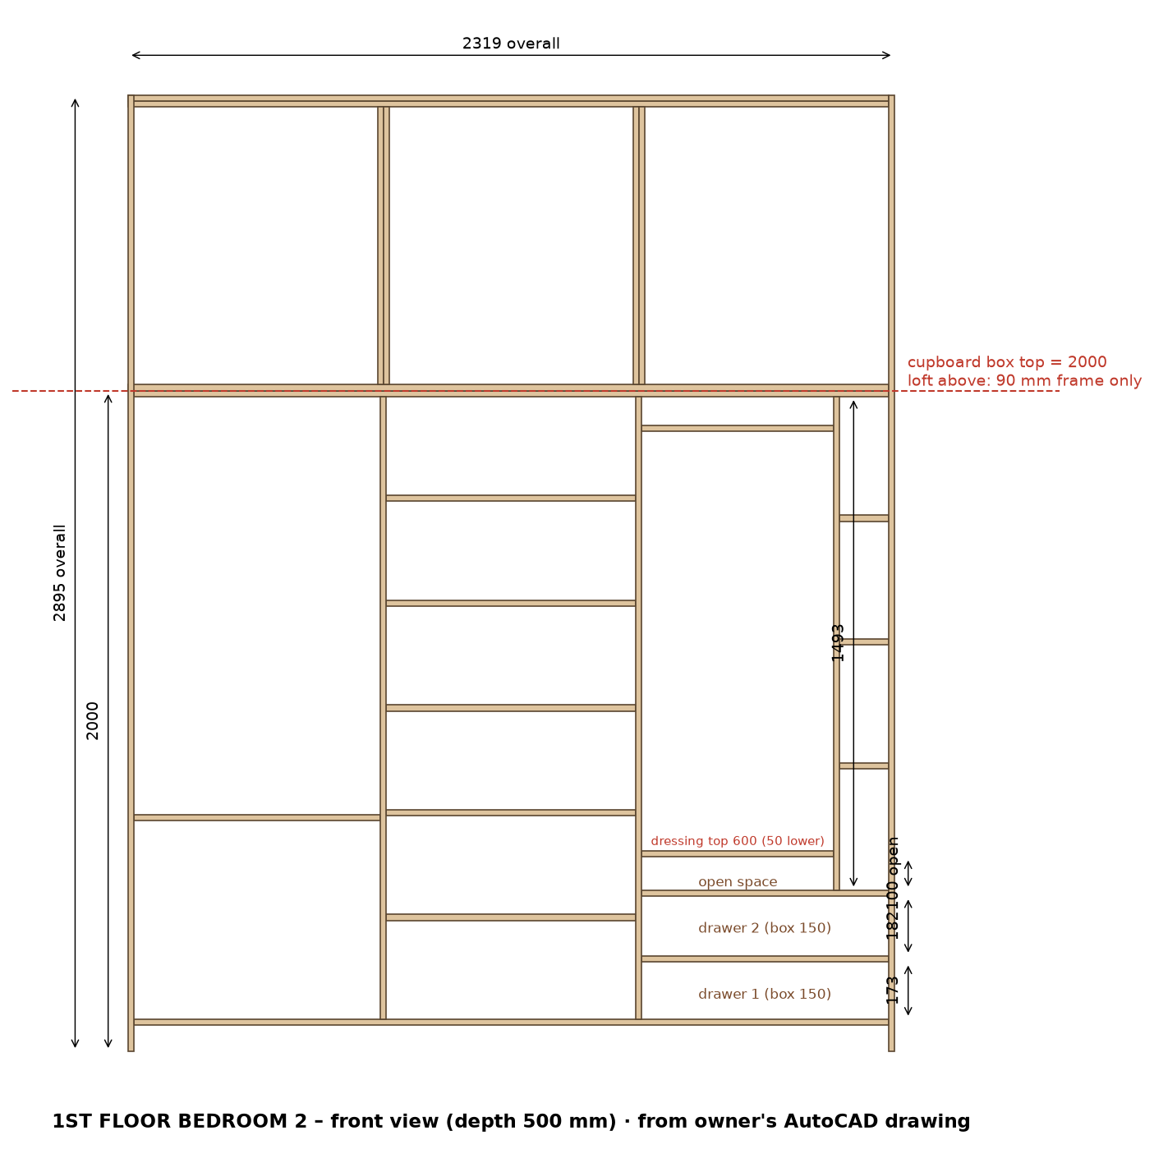
2D drawing (owner's AutoCAD): cupboard box 2000 mm high; loft above = 90 mm frame only (uprights + top/bottom rails). LED strip groove in each cupboard section.

1st Floor Bedroom 2 – shutters with Merino laminate
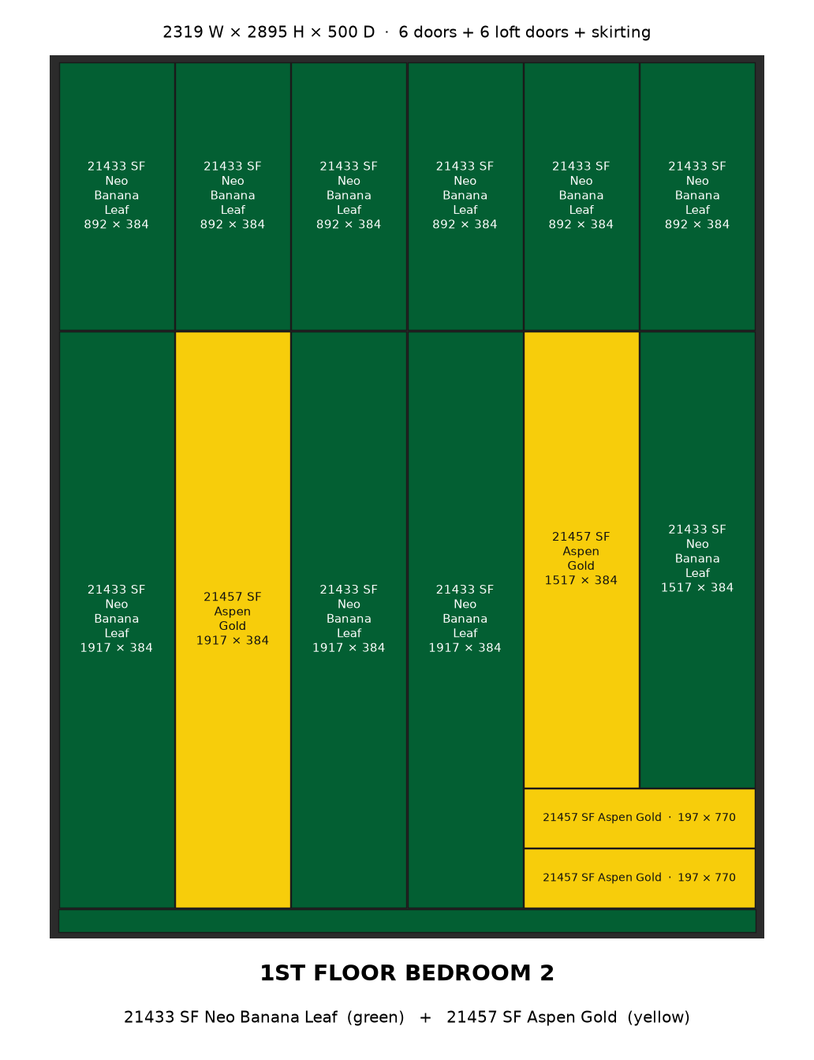

1st Floor Bedroom 2 wardrobe – cut list
# | Group | Part | Material | Qty | Finished L | Finished W | Cut L | Cut W | Edge band | Machining / note
Cupboard box
1 | Cupboard box | Bottom panel | 18 mm ply | 1 | 2283 | 500 | 2283 | 499.5 | 0.5 mm, 1 long
2 | Cupboard box | Top panel | 18 mm ply | 1 | 2283 | 500 | 2283 | 499.5 | 0.5 mm, 1 long
3 | Cupboard box | Side panel (cupboard, 2000 high) | 18 mm ply | 2 | 2000 | 500 | 2000 | 499.5 | 0.5 mm, 1 long
4 | Cupboard box | Partition (full height, doors fixed) | 18 mm ply | 2 | 1884 | 500 | 1884 | 499.5 | 0.5 mm, 1 long | 6 mm back-panel groove on both faces
5 | Cupboard box | Partition (inside) | 18 mm ply | 1 | 1493 | 494 | 1493 | 493.5 | 0.5 mm, 1 long
Loft frame 90 mm
6 | Loft frame 90 mm | Top rail | 18 mm ply | 1 | 2283 | 90 | 2283 | 89.5 | 0.5 mm, 1 long | fix to ceiling
7 | Loft frame 90 mm | Bottom rail (front, on cupboard top) | 18 mm ply | 1 | 2283 | 90 | 2283 | 89.5 | 0.5 mm, 1 long
8 | Loft frame 90 mm | Frame upright (end / partition) | 18 mm ply | 4 | 895 | 90 | 895 | 89.5 | 0.5 mm, 1 long | loft frame only - no box, no back panel
Inside
9 | Inside | Shelf | 18 mm ply | 5 | 755 | 474 | 755 | 473.5 | 0.5 mm, 1 long
10 | Inside | Shelf | 18 mm ply | 3 | 746 | 474 | 746 | 473.5 | 0.5 mm, 1 long
11 | Inside | Shelf | 18 mm ply | 2 | 581 | 474 | 581 | 473.5 | 0.5 mm, 1 long
12 | Inside | Shelf | 18 mm ply | 3 | 147 | 474 | 147 | 473.5 | 0.5 mm, 1 long
Back panels 6 mm
13 | Back panels 6 mm | Main back panel | 6 mm back ply | 1 | 1896 | 767 | 1896 | 767 | - | in 6 mm groove all round
14 | Back panels 6 mm | Main back panel | 6 mm back ply | 2 | 1896 | 758 | 1896 | 758 | - | in 6 mm groove all round
Drawers
15 | Drawers | Bottom drawers (right section): drawer front/back inner | 18 mm ply | 4 | 684 | 150 | 684 | 149.5 | 0.5 mm, 1 long | groove 8 mm wide x 10 deep: leave 12 mm from bottom edge, groove 12-20 mm (6 mm drawer bottom slides in)
16 | Drawers | Bottom drawers (right section): drawer side | 18 mm ply | 4 | 450 | 150 | 450 | 149.5 | 0.5 mm, 1 long | groove 8 mm wide x 10 deep: leave 12 mm from bottom edge, groove 12-20 mm (6 mm drawer bottom slides in)
17 | Drawers | Bottom drawers (right section): drawer bottom 6 mm (in groove) | 6 mm back ply | 2 | 432 | 702 | 432 | 702 | - | inside size + 9 mm each side (10 mm groove, 1 mm play)
Shutters
18 | Shutters | Skirting (front, base 80) - 21433 SF Neo Banana Leaf (green) | 18 mm ply + Merino laminate (shutter) | 1 | 2319 | 77 | 2315 | 73 | 2 mm, 4 sides | fix on base, 3 mm below doors
19 | Shutters | Door (full height) - 21433 SF Neo Banana Leaf (green) | 18 mm ply + Merino laminate (shutter) | 3 | 1917 | 383.5 | 1913 | 379.5 | 2 mm, 4 sides | concealed hinges, 3 mm gaps
20 | Shutters | Door (full height) - 21457 SF Aspen Gold (yellow) | 18 mm ply + Merino laminate (shutter) | 1 | 1917 | 383.5 | 1913 | 379.5 | 2 mm, 4 sides | concealed hinges, 3 mm gaps
21 | Shutters | Door above drawers - 21457 SF Aspen Gold (yellow) | 18 mm ply + Merino laminate (shutter) | 1 | 1517 | 383.5 | 1513 | 379.5 | 2 mm, 4 sides | concealed hinges, 3 mm gaps
22 | Shutters | Door above drawers - 21433 SF Neo Banana Leaf (green) | 18 mm ply + Merino laminate (shutter) | 1 | 1517 | 383.5 | 1513 | 379.5 | 2 mm, 4 sides | concealed hinges, 3 mm gaps
23 | Shutters | Loft door - 21433 SF Neo Banana Leaf (green) | 18 mm ply + Merino laminate (shutter) | 6 | 892 | 383.5 | 888 | 379.5 | 2 mm, 4 sides | on loft frame, 3 mm gaps
24 | Shutters | Drawer outside front - 21457 SF Aspen Gold (yellow) | 18 mm ply + Merino laminate (shutter) | 2 | 770 | 197 | 766 | 193 | 2 mm, 4 sides | fix on drawer box; handle
 |  | Total pieces |  | 54

Material | Area sq.ft / length | 8×4 sheets (15% waste) | Hardware / item
18 mm ply | 128.4 | 5 | LED strip light + aluminium profile (in grooves): 3 pcs, 5.08 m total
6 mm back ply | 53.1 | 2 | LED driver + door sensor switch: 1
18 mm ply + Merino laminate (shutter) | 71.5 | 3 | Soft-close telescopic channels 450 mm (pairs): 2
Edge tape 0.5 mm (front edges) | 38 m |  | Drawer handles / profile: 2
Edge tape 2 mm (shutters, 4 sides) | 55 m |  | Concealed soft-close hinges (doors): 40
 |  |  | Door handles: 6

LED strip light – profile groove cutting
Groove 12 mm wide × 8 mm deep, 100 mm from the front edge, vertical, on the panel face inside the section. Start is measured from the top of the bottom panel; groove runs up to the underside of the top panel. Drill a 10 mm wire hole through the top panel at the groove top. Keep shelf screws clear of the groove.
Section | Opening W | Panel | Groove on | From front | Groove start | Groove length | Profile + strip
1 | 746 | Side panel | right face (inside section) | 100 mm | 0 mm | 1884 mm | 1864 mm
2 | 755 | Partition | right face (inside section) | 100 mm | 0 mm | 1884 mm | 1864 mm
3 | 746 | Partition | right face (inside section) | 100 mm | 509 mm (above drawers) | 1375 mm | 1355 mm
Total |  |  |  |  |  |  | 5.08 m

2nd Floor Bedroom wardrobe
2349 W × 2825 H × 500 D · cupboard box 2000 mm + loft 90 mm frame only · cupboard clear 1884 mm
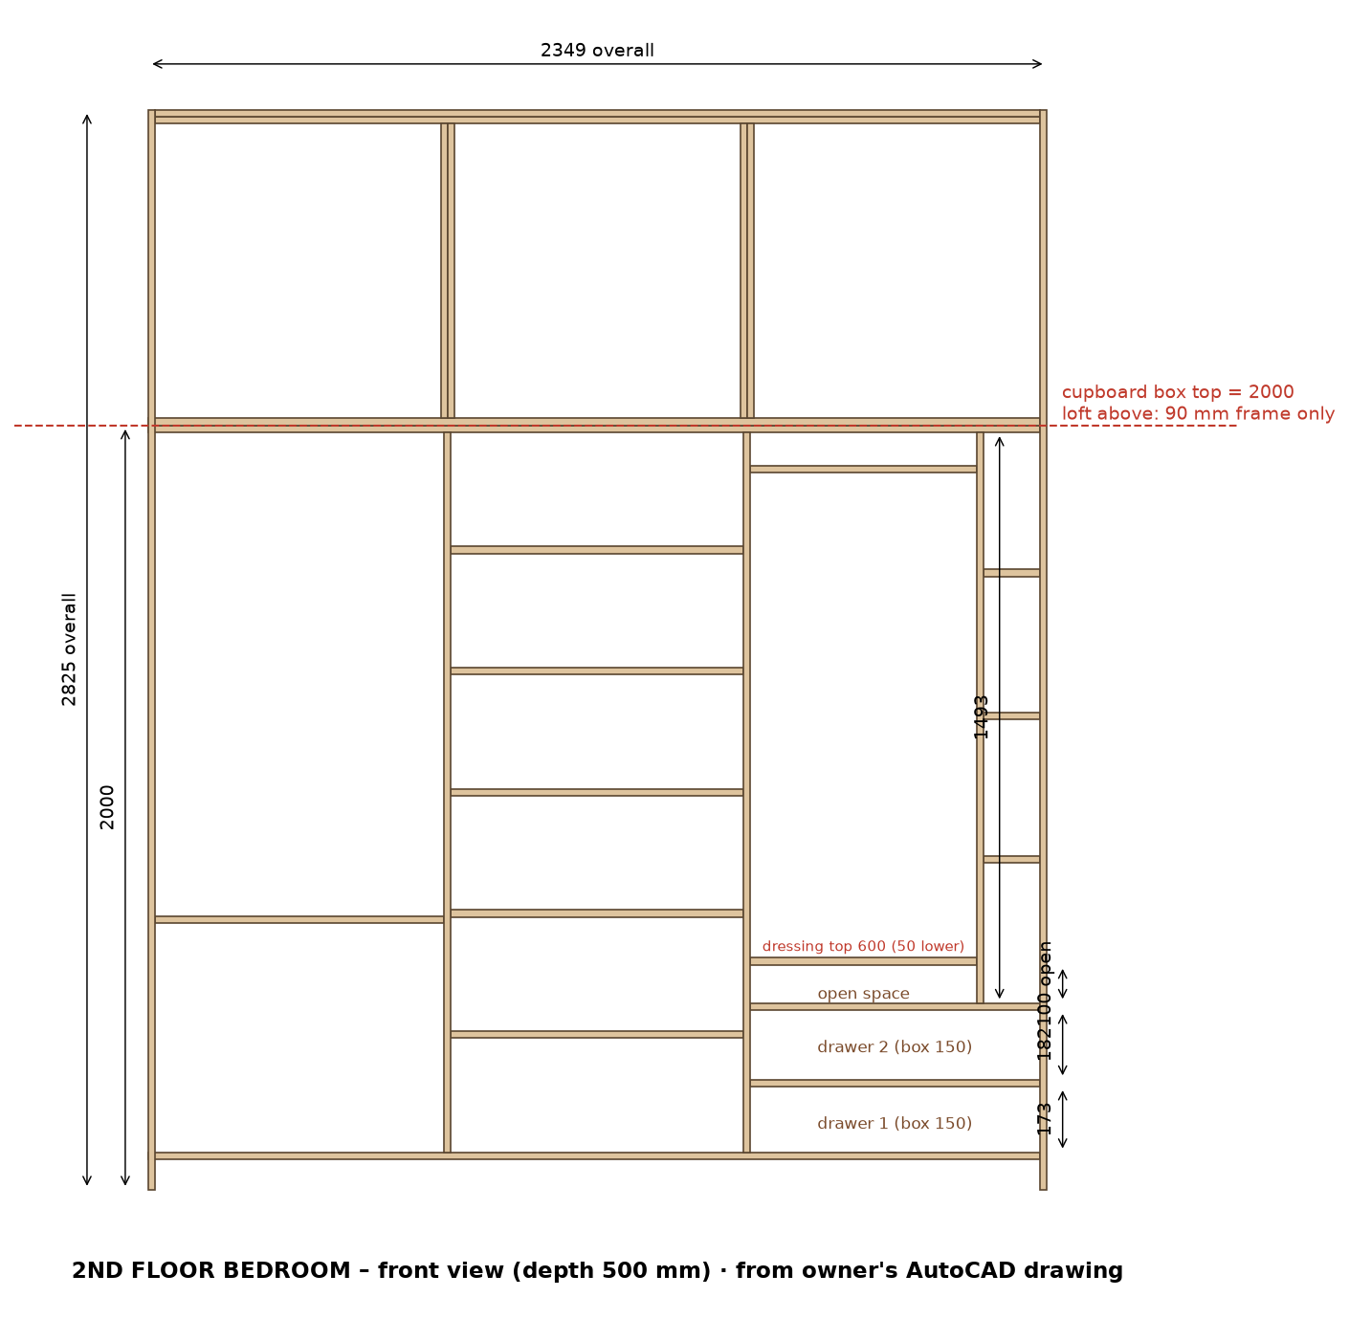
2D drawing (owner's AutoCAD): cupboard box 2000 mm high; loft above = 90 mm frame only (uprights + top/bottom rails). LED strip groove in each cupboard section.

2nd Floor Bedroom – shutters with Merino laminate
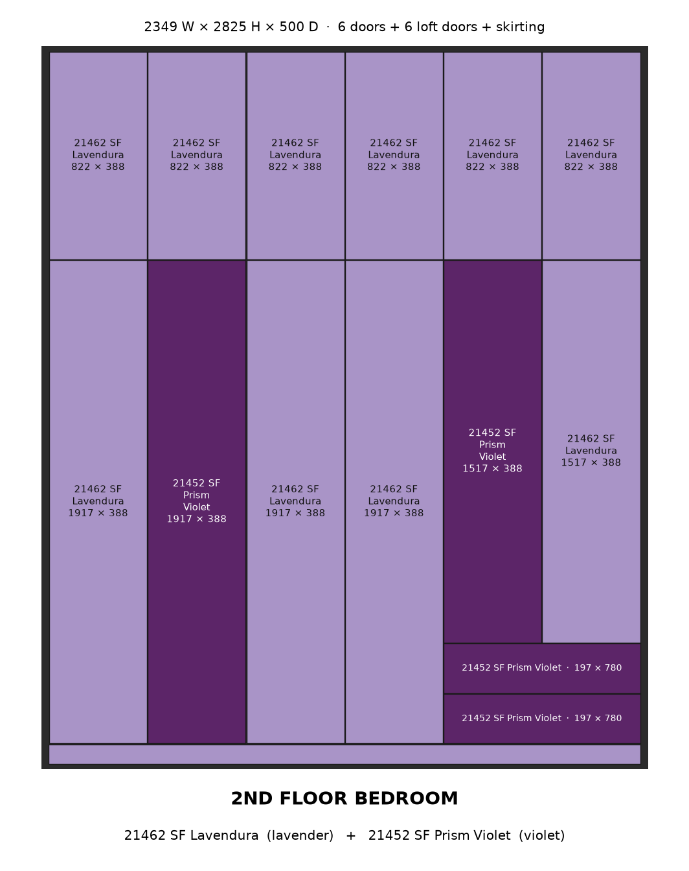

2nd Floor Bedroom wardrobe – cut list
# | Group | Part | Material | Qty | Finished L | Finished W | Cut L | Cut W | Edge band | Machining / note
Cupboard box
1 | Cupboard box | Bottom panel | 18 mm ply | 1 | 2331 | 500 | 2331 | 499.5 | 0.5 mm, 1 long
2 | Cupboard box | Top panel | 18 mm ply | 1 | 2331 | 500 | 2331 | 499.5 | 0.5 mm, 1 long
3 | Cupboard box | Side panel (cupboard, 2000 high) | 18 mm ply | 2 | 2000 | 500 | 2000 | 499.5 | 0.5 mm, 1 long
4 | Cupboard box | Partition (full height, doors fixed) | 18 mm ply | 2 | 1884 | 500 | 1884 | 499.5 | 0.5 mm, 1 long | 6 mm back-panel groove on both faces
5 | Cupboard box | Partition (inside) | 18 mm ply | 1 | 1493 | 494 | 1493 | 493.5 | 0.5 mm, 1 long
Loft frame 90 mm
6 | Loft frame 90 mm | Top rail | 18 mm ply | 1 | 2313 | 90 | 2313 | 89.5 | 0.5 mm, 1 long | fix to ceiling
7 | Loft frame 90 mm | Bottom rail (front, on cupboard top) | 18 mm ply | 1 | 2313 | 90 | 2313 | 89.5 | 0.5 mm, 1 long
8 | Loft frame 90 mm | Frame upright (end / partition) | 18 mm ply | 4 | 825 | 90 | 825 | 89.5 | 0.5 mm, 1 long | loft frame only - no box, no back panel
Inside
9 | Inside | Shelf | 18 mm ply | 5 | 765 | 474 | 765 | 473.5 | 0.5 mm, 1 long
10 | Inside | Shelf | 18 mm ply | 3 | 756 | 474 | 756 | 473.5 | 0.5 mm, 1 long
11 | Inside | Shelf | 18 mm ply | 2 | 591 | 474 | 591 | 473.5 | 0.5 mm, 1 long
12 | Inside | Shelf | 18 mm ply | 3 | 147 | 474 | 147 | 473.5 | 0.5 mm, 1 long
Back panels 6 mm
13 | Back panels 6 mm | Main back panel | 6 mm back ply | 1 | 1896 | 777 | 1896 | 777 | - | in 6 mm groove all round
14 | Back panels 6 mm | Main back panel | 6 mm back ply | 2 | 1896 | 768 | 1896 | 768 | - | in 6 mm groove all round
Drawers
15 | Drawers | Bottom drawers (right section): drawer front/back inner | 18 mm ply | 4 | 694 | 150 | 694 | 149.5 | 0.5 mm, 1 long | groove 8 mm wide x 10 deep: leave 12 mm from bottom edge, groove 12-20 mm (6 mm drawer bottom slides in)
16 | Drawers | Bottom drawers (right section): drawer side | 18 mm ply | 4 | 450 | 150 | 450 | 149.5 | 0.5 mm, 1 long | groove 8 mm wide x 10 deep: leave 12 mm from bottom edge, groove 12-20 mm (6 mm drawer bottom slides in)
17 | Drawers | Bottom drawers (right section): drawer bottom 6 mm (in groove) | 6 mm back ply | 2 | 432 | 712 | 432 | 712 | - | inside size + 9 mm each side (10 mm groove, 1 mm play)
Shutters
18 | Shutters | Skirting (front, base 80) - 21462 SF Lavendura (lavender) | 18 mm ply + Merino laminate (shutter) | 1 | 2349 | 77 | 2345 | 73 | 2 mm, 4 sides | fix on base, 3 mm below doors
19 | Shutters | Door (full height) - 21462 SF Lavendura (lavender) | 18 mm ply + Merino laminate (shutter) | 3 | 1917 | 388.5 | 1913 | 384.5 | 2 mm, 4 sides | concealed hinges, 3 mm gaps
20 | Shutters | Door (full height) - 21452 SF Prism Violet (violet) | 18 mm ply + Merino laminate (shutter) | 1 | 1917 | 388.5 | 1913 | 384.5 | 2 mm, 4 sides | concealed hinges, 3 mm gaps
21 | Shutters | Door above drawers - 21452 SF Prism Violet (violet) | 18 mm ply + Merino laminate (shutter) | 1 | 1517 | 388.5 | 1513 | 384.5 | 2 mm, 4 sides | concealed hinges, 3 mm gaps
22 | Shutters | Door above drawers - 21462 SF Lavendura (lavender) | 18 mm ply + Merino laminate (shutter) | 1 | 1517 | 388.5 | 1513 | 384.5 | 2 mm, 4 sides | concealed hinges, 3 mm gaps
23 | Shutters | Loft door - 21462 SF Lavendura (lavender) | 18 mm ply + Merino laminate (shutter) | 6 | 822 | 388.5 | 818 | 384.5 | 2 mm, 4 sides | on loft frame, 3 mm gaps
24 | Shutters | Drawer outside front - 21452 SF Prism Violet (violet) | 18 mm ply + Merino laminate (shutter) | 2 | 780 | 197 | 776 | 193 | 2 mm, 4 sides | fix on drawer box; handle
 |  | Total pieces |  | 54

Material | Area sq.ft / length | 8×4 sheets (15% waste) | Hardware / item
18 mm ply | 129.3 | 5 | LED strip light + aluminium profile (in grooves): 3 pcs, 5.08 m total
6 mm back ply | 53.8 | 2 | LED driver + door sensor switch: 1
18 mm ply + Merino laminate (shutter) | 70.6 | 3 | Soft-close telescopic channels 450 mm (pairs): 2
Edge tape 0.5 mm (front edges) | 38 m |  | Drawer handles / profile: 2
Edge tape 2 mm (shutters, 4 sides) | 55 m |  | Concealed soft-close hinges (doors): 40
 |  |  | Door handles: 6

LED strip light – profile groove cutting
Groove 12 mm wide × 8 mm deep, 100 mm from the front edge, vertical, on the panel face inside the section. Start is measured from the top of the bottom panel; groove runs up to the underside of the top panel. Drill a 10 mm wire hole through the top panel at the groove top. Keep shelf screws clear of the groove.
Section | Opening W | Panel | Groove on | From front | Groove start | Groove length | Profile + strip
1 | 756 | Side panel | right face (inside section) | 100 mm | 0 mm | 1884 mm | 1864 mm
2 | 765 | Partition | right face (inside section) | 100 mm | 0 mm | 1884 mm | 1864 mm
3 | 756 | Partition | right face (inside section) | 100 mm | 509 mm (above drawers) | 1375 mm | 1355 mm
Total |  |  |  |  |  |  | 5.08 m

